3331 Assignment 2

Zaid Albirawi  
250626065

1. Let $L=\left\{ω∈{\left\{a, b, ∪, ε, \left(, \right), *, +\right\}}^{*} \right| ω is a syntactically legal regular expression over \sum{=\{a, b\}}\}.$
   1. Give an unambiguous context-free grammar that generates *L*. The grammar should
      1. Use the following precedence levels, from highest to lowest: (1) \* and + (equal precedence), (2) concatenation, and (3) $∪$ and
      2. left-associate operators of equal precedence. $$G=\left\{\left\{S, E, T, J, id, a, b, ∪, \left(, \right), *, +\right\}, \left\{a, b, ∪, \left(, \right), *, +\right\}, R, S\right\} \\ R=\left\{S→S∪E \right|E,$$ $E→ET | T,$ $T→J^{*} \left| J^{+} \right| J,$ $J→\left(S\right) | id,$ $id→a|b|ϵ\},$
   2. Show the parse tree that your grammar produces for the string $\left(a∪b\right)ba^{*}$.  
      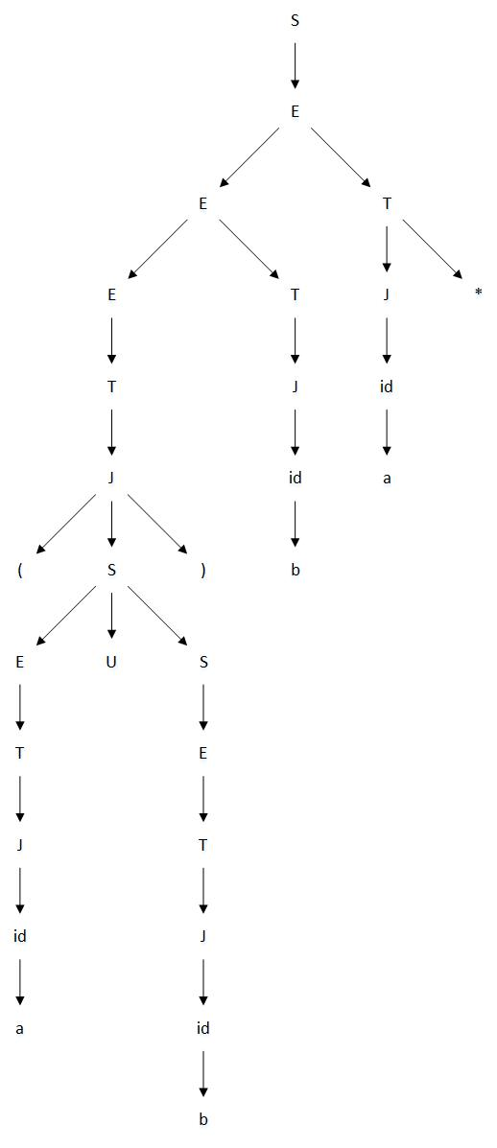
2. For each of the following languages *L*, prove whether *L* is regular, context-free but not regular, or not context-free:
   1. $\left\{xy \right| x, y∈{\left\{a, b\right\}}^{*} and \left|x\right|=|y|\}$.  
        
      This language is regular because it is a language that contains all the strings of even lengths. Which is proven to be regular by this FSM:  
        
      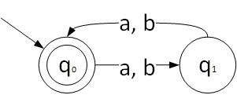
   2. $\left\{a^{i}b^{n} \right| i, n>0 and i=n or i=2n\}$.  
        
      This language is not regular as it does not satisfy the pumping lemma. However, it is context-free as it can be represented by the following grammar: $$S→A | B \\ A→aAb \\ A→ab \\ B→aaBb \\ B→aab$$
   3. $\left\{{\left(ab\right)}^{n}a^{n}b^{n} \right| n>0\}$.  
        
      This language is not a context-free language as it does not satisfy the pumping lemma.  
        
      Proof:  
      Let ${\left(ab\right)}^{k}a^{k}b^{k}=uvxyz$, where $\left|uvx\right|<k$ and $vy>0$  
        
      since $vy$ has to be more than 0, then every time $vy$ is pumped into the expression, it will cause an imbalance in the expression which results into taking that expression out of the language. For example, if we pump $vy$ we can get the expression ${ \left(ab\right)}^{k+m}a^{k}b^{k}$ or ${\left(ab\right)}^{k+m}a^{k+m}b^{k}$, which are outside the language. Therefore, this language is not a context-free language.
   4. $\left\{ωω^{R}ω \right| ω∈{\left\{a, b\right\}}^{*}\}$.  
        
      The language is not context-free.  
        
      Proof by the pumping lemma:  
      Let $a^{k}b^{k}b^{k}a^{k}a^{k}b^{k}=uvxyz$, where $\left|uvx\right|<k$ and $vy>0$  
        
      since ${\left|ω\right|}_{1}=\left|ω^{R}\right|={\left|ω\right|}_{2}$, then wherever we pump in this expression it will go out of the language. If the expression in pumped in b then $a^{k}b^{k}b^{k+m}a^{k}a^{k}b^{k}$. If the expression is pumped in between the a and b then ${ a}^{k}b^{k}b^{k+m}a^{k+m}a^{k}b^{k}$. Therefore the language does not satisfy the pumping lemma.
3. Show that the following problem is decidable: Given a context-free grammar *G,* does *G* generate any even length strings?  
     
   Firstly, use the algorithm CFGtoPDAbottomup(G) to build a PDA, P, that takes in L(G). Secondly, construct a FSM, F, that accepts all even strings from L(G). Furthermore, use the intersectPDAandFSM(P, F) algorithm to generate a PDA P\* that accepts all the expressions that belong to the intersection of P and F. Finally, use the decideCFLempty(P\*) algorithm to determine whether the problem is decidable or not. If the CFL is empty then return false, else return true.